**Plot-buttons:**

Reset view to original position (the same as the “Reset view” button)

Zoom/Move view-history (backwards/forwards)

 - Leftclick + drag = Move   
- Rightclick + drag = Zoom

Rightclick + drag = zoom to selected window

 Plot layout settings (margins etc.)

 Extensive plot settings (line colors etc.)

Save current figure

**Buttons:**

**Update:** Replot figure using current settings (plot_range, normalization settings etc.) **Replot view:** Set the plot_range to the current x-range view, for example:

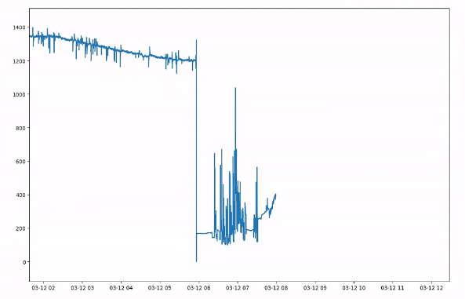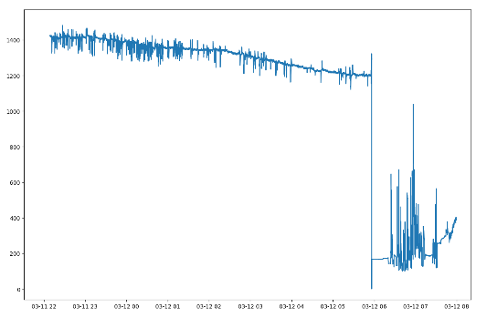 Moved right using



Then 

Results in:

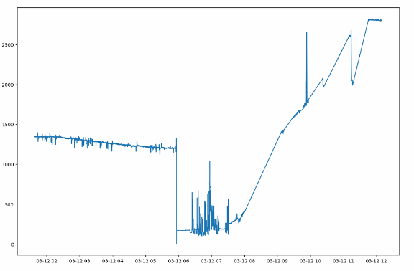

**Settings:  
Normalize:** Whether normalization should be used

**Fft :** Whether to plot frequency-spectrograms (don’t do this for too much data at once, since this might slow things down).   
  
**plot_range:** The current time-window that is being plotted (drag the slider underneath to select a percentage of the

**Plot Columns:** What sensordata should be plotted (don’t select non-numeric data, as this is not handled yet and might result in a crash)   
  
**X_axis:** What data to use as x-axis

**Loading data:**

As of now, the tool supports loading pre-created “.pkl” datasets, these can be found under:   
C:\Users\31654\Dropbox\DATALOGGER Twente\Data\Ruwe data cleaned

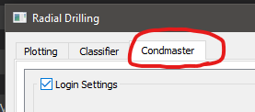**Loading Condmaster data:**

Go to the condmaster tab.

We can now see a list of the data-retrieval settings.

The *Login settings* tab contains all data necessary to connect with the CES server to retrieve the data. This should be changed as needed.

**NOT YET IMPLEMENTED:** *Techid Settings* contains all data, the first column denotes the TechID of the corresponding sensor. The second column denotes the short-name for a sensor property. E.g. the pump vibration data is called “PumpFFT”. Multiple sensor properties can exist per sensor

The third column denotes the location in the Condmaster request, e.g. in this case:



The pump fft data can be found under “FFT > FFT” in the request responses.

“Save config” saves the current config for future use (not yet implemented)  
“Set Default Config” saves the current config as the default config in the “Data” folder, if such a config is found, it is loaded when the button is clicked(not yet implemented)

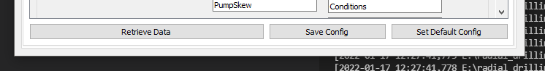**To retrieve data:** fill in valid CES settings and click on the “Retrieve Data” button (this is implemented)